A Better Soar System

This document gives a (very) brief overview of the Soar Technology vision of system development with Soar. Hopefully, this vision will guide future development of components and tools around the Soar kernel.

What we have now

To help better understand where we want to go with Soar it is beneficial to take a look at where we are. To that end, in figure 1, we present an abstract architecture diagram of most of the system components used by Soar Technology. The lines in the diagram indicate communication with the other modules/systems/components.

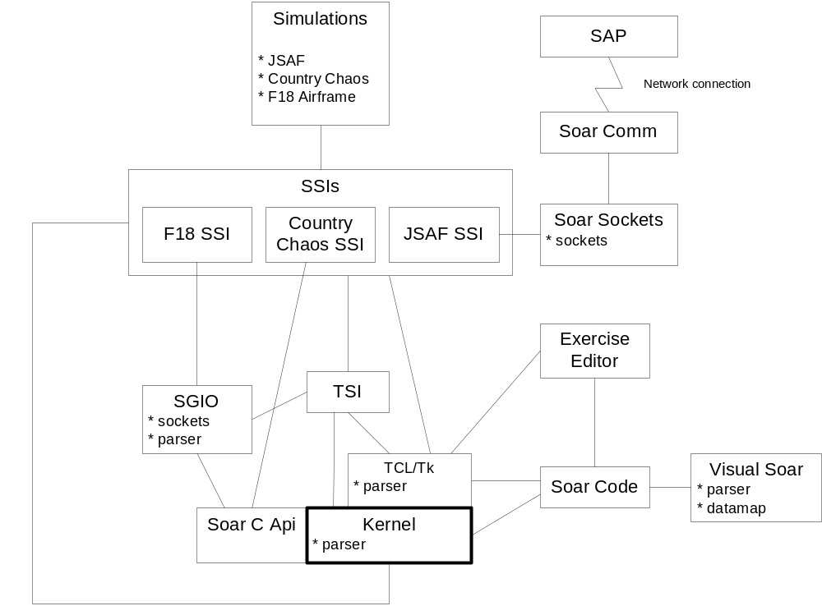
Figure 1: Current Soar system state

Currently, Soar systems are custom built for each application. Each application interfaces in a different way with the kernel, often multiple ways, though all share connections with TCL. The following are problems with our current approach:

No standard interface (including implementation). Currently, the Soar Simulation Interface (SSI) developer must interface with the kernel, TCL/Tk and the TCL Soar Interface (TSI) to get full Soar functionality. Both the kernel and the TSI do not have API’s, they are simply a collection of functionality. This makes designing an SSI difficult and error prone. It is easy to misuse the kernel and TSI because there is no definition of how to use them (other than previous implementations). All SSI’s provide some added layer of abstraction from the kernel in order to make the SSI more dependable and maintainable. Most of this abstraction is similar (or exactly the same) in each SSI and should be shared. Currently, this lack of a low-level interface is the biggest single problem with Soar systems, and it is worth enumerating the issues related to this problem:

- The interface layer is a major source of bugs (including crash bugs) in current systems, especially newly built systems. Why?
  - There is no accurate documentation for the Soar kernel or its wrapper APIs so there is no way to know how to use them.
  - The kernel and TSI encapsulate very little, and it is easy to incorrectly manipulate Soar kernel state.
  - The kernel and TSI maintain separate state information, which leads to synchronization bugs (kernel configured one way, TSI configured another).
- It takes too much time to interface Soar with any given simulation (weeks instead of days).
- There is a strong dependency on TCL, not necessarily in the kernel, but in the SSI. Why? Because some of the Soar system functionality is only available through the TSI (TCL Soar Interface). This includes the debugger. Many times we would like to not have to link to or use TCL in our simulations.
- The interface restricts what we can do with more advanced systems (e.g. COM/CORBA systems, distributed systems, etc) because we spend too much time on the lowest level of the interface development. We don’t have time for advanced interactions.
- It encourages bad development practices in connected systems. It is easy to write a poorly designed and implemented system that connects to Soar. Why? Because you HAVE to hack and improvise to make what you want to happen work. Also, so much time is spent at the lower levels figuring out what is happening that there is little project time left for good designs or improved interfaces.
- It is difficult to share external components (e.g. SAP, socket libraries, etc). Most of these libraries are built on custom interfaces into Soar that obviously don’t port well.

Interfaces also include data exchange standards and communication mechanisms. Some components in the system separate themselves at some level from the kernel and TCL (e.g. SAP), but introduce other problems:

- Their core code or underlying libraries are based on specific SSI implementations.
- Communications are custom for each application. Maybe they share a socket library, but they don’t share a communications protocol.

At this point, most of the external Soar tools are completely independent of each other. It is never in the scope of a tool building project to build a standard for system-wide interfaces or communications (and it should not be).

Another issue that plagues the current system is duplication of effort and lack of shared services. Some of this is highlighted in the diagram with the highlighted features in the boxes. There are at least four implementations of code to parse or partially parse Soar productions and files of Soar productions. None of these are based on a specification or grammar (except, perhaps, the kernel parser) and none of them are fully functional. Furthermore, none of them are robust (it is relatively easy to crash many of the systems with incorrectly formatted production code).

Socket libraries are another example. There are at least two implementations of socket libraries available, one in SGIO and one in Soar Sockets. Neither of which is packaged to be reused at a system level (though Soar Sockets is perhaps close). Furthermore, while both implement the lowest-level socket interactions, the systems that use these libraries miss the main point of socket communications – the “communications” part. The network streaming is easy; it is the standardization of how to talk to an agent that is the important and the harder part that would make these pieces truly useful at a system level.

This brings us to one of the core issues with current systems: components are not built to serve other components or systems. They are built to fit into a particular structure and solve a very narrow range of tasks. It is easy to say “hey, Visual Soar has a parser, let’s reuse it,” but much harder to actually do it because the parser was not designed or built to be used that way.

There have been efforts to improve various aspects of Soar systems, from the lowest level interfaces up to high-level tools. A valid and useful question is, “why not use these tools instead of building a set of new interfaces and tools?” There is a simple answer that is only partly correct. That is that current tools do not do what is needed. For each tool that has been built there is a list of functionality that either doesn’t exist, doesn’t work correctly, or isn’t useful. However, these types of problems can be fixed by improving the tools. There is a more fundamental problem behind the current tools: they are all independent of each other and do little to improve the system as a whole. In fact, not one piece solves or even significantly improves on the problems discussed above. What is needed is a system level engineering solution that standardizes the way components talk to each other in Soar so that extensions can be dropped in and changed easily.

The two pieces that come closest to solving some of the lowest level issues are the Soar C API and the SGIO. But these interfaces bring up good questions like “why do they BOTH exist, which do I use, and can I use both together?” It is worth examining more closely why these two components do NOT solve the issues listed above:

Soar C API

- The Soar C API is not robust. Testing and bug fixes can help this, but some robustness issues are related to the design (no encapsulation!)
- The Soar C API does not hide much from the user. It is not significantly easier to use the Soar C API than to make raw kernel calls.
- The Soar C API does not cover enough use cases in Soar.
- The Soar C API is not easy to use. It is a wrapper around Soar designed to match Soar, not to match the end user. This is probably the worst problem and the most difficult to repair (you would have to redesign it!)
- The Soar C API is not well documented.

SGIO (Soar Games Input Output)

The SGIO is at an interface level higher than the Soar C API, and depends on the Soar C API at a lower level.

- The SGIO is not robust.
- The SGIO is not extensible or configurable. It is built for one purpose (interfacing Quake to Soar) and does that fine, but other things it does less well.
- The SGIO interfaces are poorly designed.
  - Inconsistent levels of abstraction
  - Inconsistency in general naming, structuring
  - Poor coverage of task space (can’t do what we want!)
- The SGIO does not encapsulate many of Soar’s low-level constructs (WME’s, input/output links, etc).
- The SGIO is not well documented.
- The SGIO is poorly version controlled.

At a slightly higher level of abstraction these interface wrappers exists perhaps the best current example of design in Soar systems (beyond the kernel itself) – the Soar Socket and Soar Comm libraries. They have the advantages of being packaged as independent libraries while their scope of operation is somewhat more general than the tasks they are currently solving. However, they still suffer from general issues (g) and (h) above, as well as suffering from the not built to serve problem discussed earlier. Furthermore, these libraries are poorly documented, and have never yet been used outside of the narrow domain into which they were placed.

A better way is needed.
A better way

A better way is to start from the system level, determine what we do currently, what we will be doing in the future, and how we would like to do it. “System level” means the solution is NOT a better low-level API, a more robust parser, a reusable socket library, a better editor, or object-oriented extensions to Soar. “System level” means the solution is ALL of those things combined with well designed, documented and standardized mechanisms and protocols for interconnecting and communicating between these pieces.

Furthermore, as a system level design is produced and implemented, we need to ask the following questions that are outside of the scope of any one project:

1. How can components be configured to provide services to other components?
2. How should components communicate with each other?
3. How should agents communicate with other system components?
4. How does/should the system as a whole get/be used?
5. How can we make the components and the system robust?
6. How can we improve quality and accessibility of system documentation?
7. Where are the bottlenecks in building and using Soar systems?

How to do it a better way

Building a better system design and implementation that encompasses all of the functionality currently available is obviously a time consuming effort. A reasonable estimate is impossible without a design on which to base it, but it is safe to say it would be in the man-years (plural) range and could reach into the 10s of man-years. It is not desirable or even possible to halt all current progress and attack Soar system development as one giant project that fixes everything.

One possible approach is a multi-pronged approach as follows:

- Understand the system level issues and build a vision as to what Soar systems should look like in the future.
- Build a design for system level interactions and services. This design should focus on communications between components (and agents).
- Evaluate what we have in the context of the new design:
  - Build the services most critically needed.
  - Adapt and redesign components that come close to meeting system specifications.
- Build a repository of Soar system components, documentation and technology.
- Monitor projects from a system level to achieve the following:
  - Guide project-level designs with system-level insights and designs.
  - Guide system-level design with the knowledge of how each is being used.

Because of the tight budgets and research nature of most projects, it is probably NOT the correct solution to force all projects to take the extra effort to make sure all of their reusable components are packaged or designed for use at a system-level. A better approach could be to treat projects components as prototypes for system-level components. If components work well in that project, evaluate the component(s) usefulness at a system level and decide if it is worth redesigning and implementing for reuse. This redesign and implementation could be IR&D or it could be part of another project that is attempting to reuse components from other projects. Once a component meets system level requirements, it should then be documented more thoroughly and placed under version control.

This model leads to layered systems as shown in figure 2. The core functionality of most systems is a set of reusable, well-tested components. The primary work associated with each project is then adapting and extending the current technology to meet project goals. This adaptation leads to a layer of components that are more cutting-edge but not as well tested. Some of these components can be made part of the core if they serve a system-level purpose.

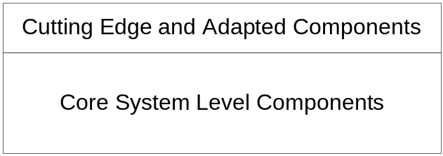
Figure 2: Core system with project-level components built on top.

What the better way might look like, at the highest level

Figures 3 and 4 are system level diagrams showing more consistent component interactions. Obviously, this diagrams do not address all issues that need to be resolved. They are only two views of a complex system. However, they shows, at an abstract level, how a better system might be architected.

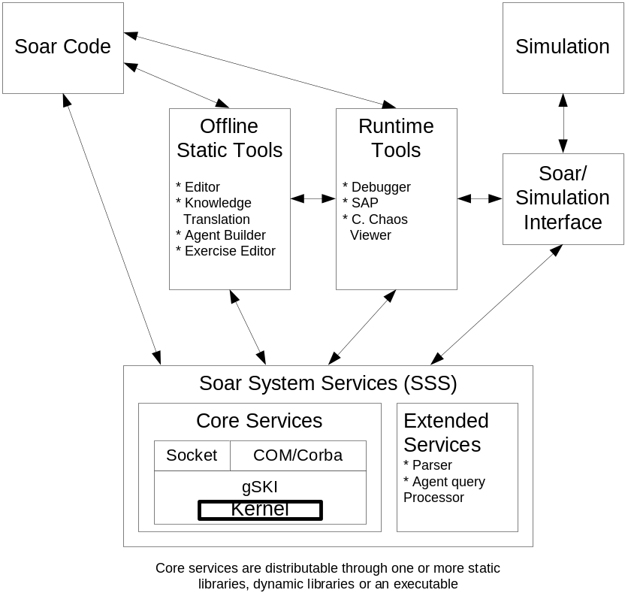
Figure 3: Diagram of Soar system components and libraries

Figure 3 gives a component-oriented view of the new Soar system architecture. It focuses on the classification of components and clearly delineating the dividing lines between component classes. The responsibilities of each of these components/modules is as follows:

Kernel: The Soar kernel provides the implementation of the Soar architecture. It is responsible for managing the rete, WME memory, production matching and all of the other parts of the Soar architecture and infrastructure.

gSKI: The gSKI is responsible for providing a low-level, C++ interface into the Soar kernel. Any interaction that requires talking to the Soar kernel must go through the gSKI. This includes I/O interactions, agent configuration, debug information and more. Note: what the gSKI does would likely be implemented as the interface into the kernel itself, if the kernel were rewritten.

Socket: The socket interface module is responsible for providing access to the kernel though a socket connection. Basically, this means that the socket interface maps requests from a socket connection to gSKI calls. Above the socket layer should be defined a protocol for interacting with the agents over sockets.

COM/Corba: The COM/Corba modules are responsible for mapping the gSKI interface to the COM/Corba specifications. This would allow the Soar kernel to be easily inserted into things like VB or Python applications.

Extended Services: Extended services are utility components or modules that provide services that can be shared by several parts of a Soar system. An example would be a Soar file parser, which may be accessed by the kernel, an editor, and a debugger. These components are physically separated from the kernel and the kernel’s interfaces (that is, they are separate libraries); however, they should be part of the Soar System Services distribution.

Offline Static Tools: Offline static tools are tool that do not typically interact with a running soar system. They include things like editors, agent configuration/build tools and knowledge translation tools. They may need to interface with the Soar System Services, thus the link to the Soar system services.

Runtime Tools: Runtime tools need to interact with a running system. These types of tools include debuggers and Situation Awareness Panels (SAPs). They should interface with the kernel through the socket or COM/Corba layer, thus allowing them to be stand-alone, separate processes.

Soar Simulation Interface (SSI): The SSI is the layer between a simulation and the Soar System Services. It is responsible for mapping simulation interfaces to the gSKI (or Socket/COM/Corba) interface. This layer should be as thin and as configurable as possible to allow Soar to be easily inserted into a simulation.

Simulation: The simulation is the “world” Soar agent’s live in and interact with. Simulations are generally out of our control, so our system must be able to adapt to different simulation technologies.

Soar Code: Soar code is the data driving Soar systems. It is created by the offline tools, processed by the Soar System Services (most notably, by the Soar Kernel) and inspected by the runtime tools.

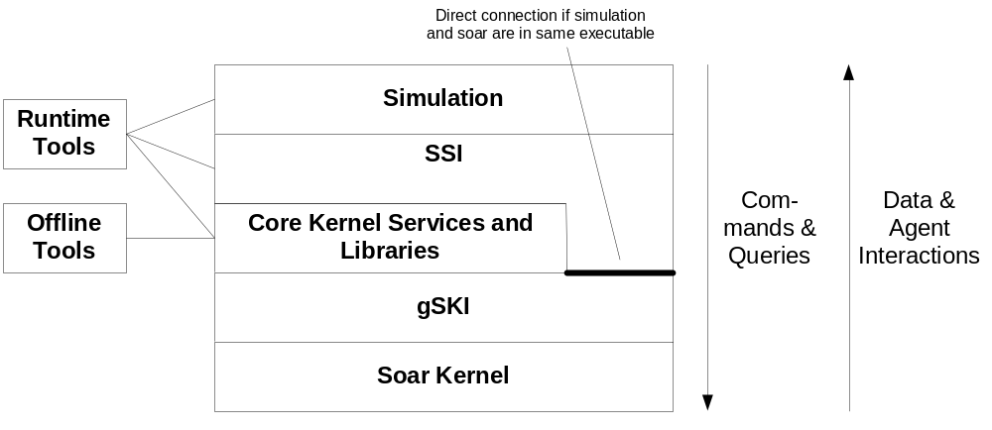
Figure 4: Diagram of system components focusing on separation of communication layers

Figure 4 is layer-oriented and focuses attention on the separation of communications into several layers. The large block in the middle is typically a single executable, but does not have to be. However, if the Soar kernel and the simulation are in two different executables, the direct connection between the SSI and generic Soar Kernel Interface (gSKI) will not exist. Components in each block can only communicate with the blocks it is adjacent to or to those it is connected to with lines.

Description of components:

1. Core and Extended Kernel Services and Libraries: At the center of all Soar systems will be the Core and Extended kernel services. It should probably consist of multiple small static/dynamic libraries that are exposed through a consistent, extendable set of interfaces. It should be based on a low-level C++ wrapper, i.e. the generic Soar kernel interface (gSKI), encapsulating the kernel to make using the kernel correctly simple and using it improperly very difficult. Socket-based and COM/CORBA interfaces should be provided here as well to allow systems to be built from multiple processes/applications. Providing these interfaces at a level just above the gSKI allows communication techniques and protocols to be standardized and reused by multiple simulation systems and tools. This multi-process abstraction will especially help tool development and allow things like debuggers and editors to be built as separate applications that attach and interact with agents in real time. Extended low-level libraries of things such as right-hand-side functions, production parser(s), preprocessors and other common extensions (requiring efficiency) should also be provided as extended services (extra components, not part of the kernel) to allow all other components to take advantage of them.

2. Soar Code: Soar code can continue to exist as it does now as independent text files. However, Soar code should cease to include external system specific code (e.g. TCL) unless embedded external languages is really the only way to get the job done. Furthermore, no constraints should be placed on Soar files by the tools if possible (e.g. particular formats, comment styles or directory structures). The only constraint that should be placed on Soar code is that it can be successfully parsed by the parser(s) available to the extended services. And no matter what the code looks like, the system should never crash due to Soar code input.

3. Offline Static Tools: Offline static tools include anything that helps write, edit, or translate to/from Soar code (excluding core system parsers). A current example would be Visual Soar. A cross-process communication infrastructure (e.g. sockets) in the core services will allow these applications to communicate directly with the running agents and with debuggers (if desired).

4. Runtime Tools: Runtime tools include any application or component that requires communication with a running agent to be useful. These tools include debugger(s) (like the TSI), situation awareness panels (SAP), or other agent insight tools. These tools should be able to communicate across processes to the running agents. However, the system should also support in-process attachment to these tools (e.g. using the standard C++ or COM/CORBA interfaces).

5. Soar Simulation Interface (SSI): Any simulation is going to need a layer of code to interface the Soar kernel to the simulation. With a properly designed gSKI and set of core services, this task should be no more than a few days work for most simulations. Ideally, this might be done, and possibly should be done, through data files (e.g. XML) and scripts. The worst case should be interfacing through a well-organized and encapsulated standard C++ interface.

6. Simulation: The host simulation should be completely independent of the kernel, the Soar language, and TCL. It should interface only with the SSI.

